**EXPERIMENT -7**

**Problem Statement-**

Develop a machine learning method to predict how people will rate movies, books etc.

**Algorithm**

**2Rs. Algorithm**

Linear regression is perhaps one of the most well known and well understood algorithms in statistics and machine learning.

In this post you will discover the linear regression algorithm, how it works and how you can best use it in on your machine learning projects. In this post you will learn:

Why linear regression belongs to both statistics and machine learning.

The many names by which linear regression is known.

The representation and learning algorithms used to create a linear regression model.

How to best prepare your data when modeling using linear regression.

You do not need to know any statistics or linear algebra to understand linear regression. This is a gentle high-level introduction to the technique to give you enough background to be able to use it effectively on your own problems.

**Program Screenshots**

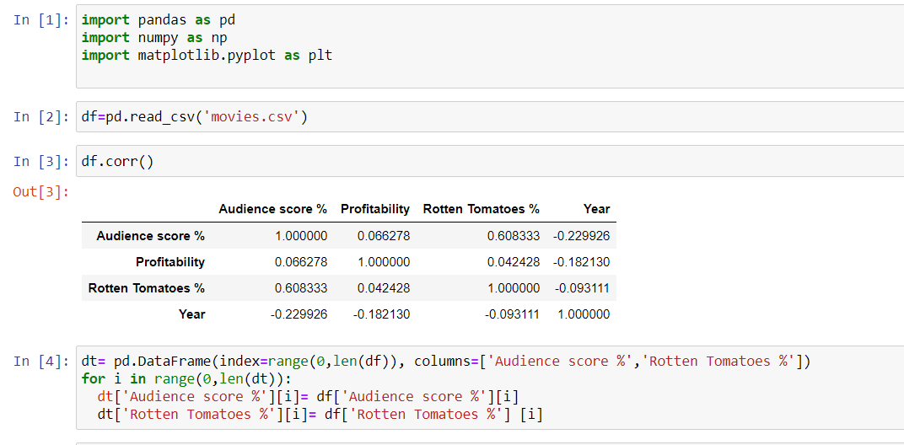

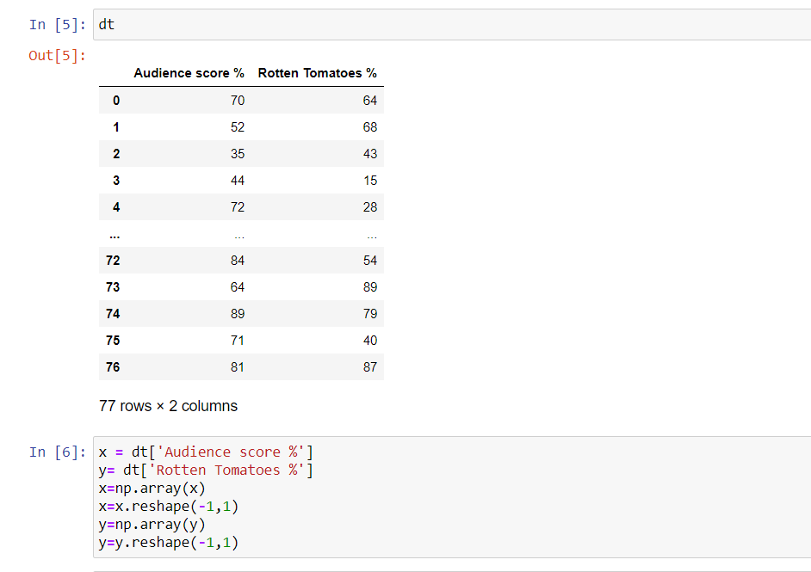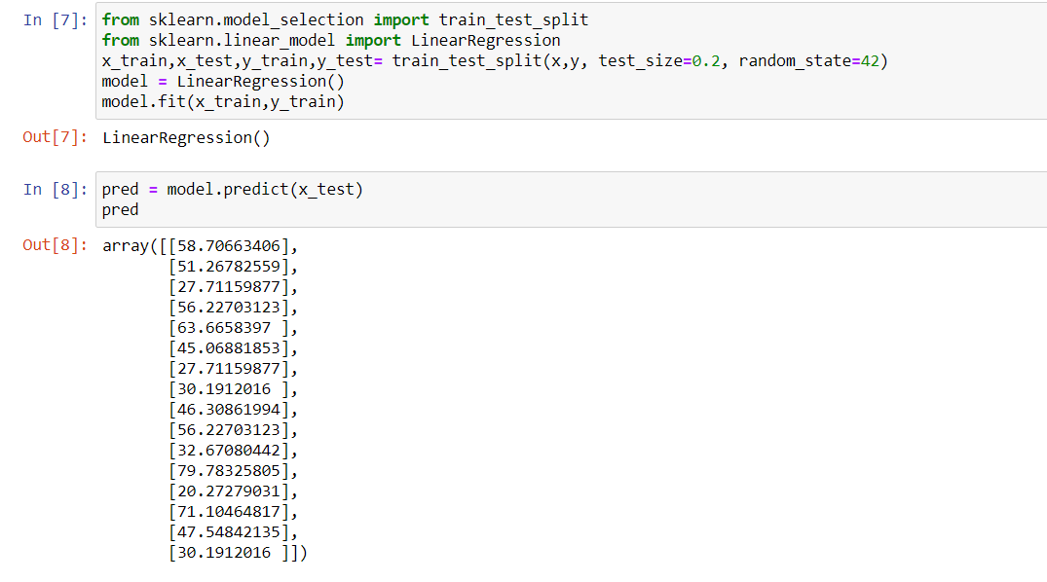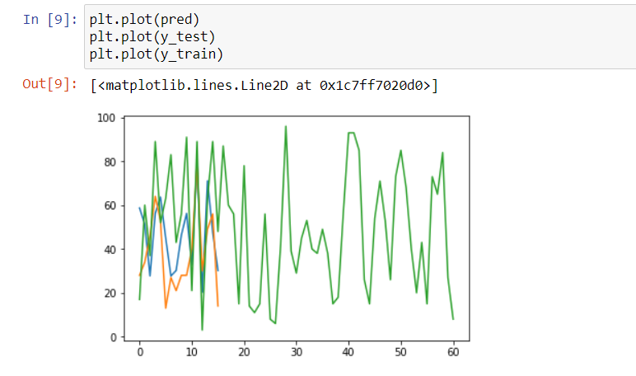

**Github Link-**

<https://github.com/gurkiratsingh-1/ML_Assignment_Gurkirat/blob/main/LAB/ML%20Experiment%207.ipynb>